Neonatal hypothermia is a contributing factor to neonatal mortality and morbidity. It is associated with a higher risk of infants developing hypoglycemia, jaundice, respiratory distress syndrome, sepsis, and suffering from intraventricular hemorrhage. This guide is being provided to help your team establish protocols, processes and education to prevent neonatal hypothermia. See the ALPQC Neonatal Hypothermia Prevention website for more resources.

Step 1 – Gather your QI team:
Your team should contain AT LEAST one physician champion, one nurse champion, and one data champion (someone with access to medical charts). Examples of other team members that would be helpful to include are:
- Physician providers (ex. Neonatologists/Pediatricians, hospitalists, emergency medicine)
- Nurse leaders from each of the above-listed areas
- Front-line champions (ex. Charge RN)
- Hospital or unit administration
For helpful information regarding how to form a successful QI team, please visit: https://www.ihi.org/resources/Pages/HowtoImprove/ScienceofImprovementFormingtheTeam.aspx

Step 2 – Identify gaps, goals, and next steps:
- Review the toolkit/checklist as a team to:
  - understand best practices
  - identify current gaps & determine action steps needed
  - Assign someone to be responsible for championing and managing each action
- Identify an area for a pilot
- Set goals for improvement
- Develop protocols, or tweak existing ones, to meet goals

Step 3 – Ensuring success
- Determine a method for gathering data to monitor project success
- Establish an internal QI team meeting schedule (potentially bi-monthly at first and then monthly)
- Commit to participate in monthly ALPQC Neonatal/Pediatric Action Period Calls
- Participate in monthly 1:1 ALPQC Quality Improvement RN calls

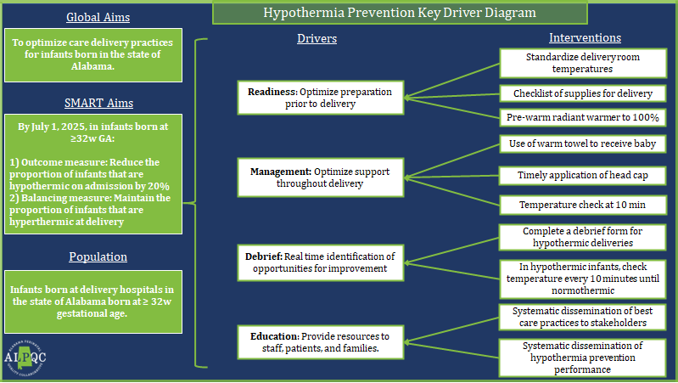
ALPQC Neonatal Hypothermia Prevention Initiative Project Checklist
This checklist was developed based on action items identified by the ALPQC to optimize neonatal hypothermia prevention and care delivery practices for infants in Alabama.
Action | Current Assessment | Responsible Person
- Readiness
Develop standardized processes for optimizing preparation prior to delivery to prevent neonatal hypothermia. | ___Need to educate on existing policies
 | ___Need to improve existing policies
 | ___Need to develop new policies
Checklists are in place to ensure equipment and supplies needed to support normothermia are readily available prior to delivery. | ___Need to educate on existing policies
 | ___Need to improve existing policies
 | ___Need to develop new policies
- Management
Ensure a written protocol is in place to support standardized interventions to optimize normothermia throughout delivery (example: radiant warmer, skin-to-skin, pre-warmed blankets, head cap) | ___Need to educate on existing policies
 | ___Need to improve existing policies
 | ___Need to develop new policies
- Debrief

Complete a team-based debrief form for hypothermic deliveries with real-time identification of opportunities for improvement, including:  - In hypothermic infants, check temperature every 10 minutes until normothermic | ___Need to educate on existing policies
 | ___Need to improve existing policies
 | ___Need to develop new policies
- Education

Provide evidence-based education to staff, patients, and families regarding best practices for newborn hypothermia prevention, including recognition of signs and symptoms. | ___Need to educate on existing policies
 | ___Need to improve existing policies
 | ___Need to develop new policies

