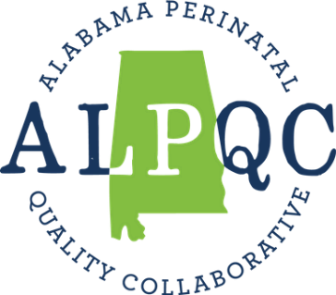

Neonatal Hypothermia Prevention
Initiative

Getting Started Kit

November 2023

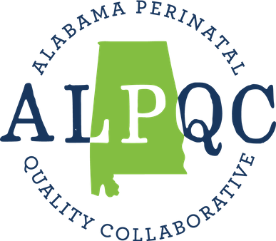

Table of Contents

An Overview of the Neonatal Hypothermia Prevention Collaborative 3
Contact Information 5
Collaborative Schedule 5
Getting Started Checklist 6
Step 1: Review Collaborative Charter and Toolkit 6
Step 2: Team Formation 7
Step 3: Fill out the ALPQC NHP Initiative baseline survey 10
Step 4: Become familiar with resources in NHP Initiative website 10
Step 5: Become familiar with the Model for Improvement 10

Adapted from IHI Breakthrough Series College Workbook

An Overview of the Neonatal Hypothermia Prevention Collaborative

Welcome to the Neonatal Hypothermia Prevention (NHP) Collaborative. The aim of the Neonatal Hypothermia Initiative is to reduce by 20% the proportion of infants that are hypothermic on admission by July 1, 2025, in infants born in Alabama at ≥32 weeks gestational age.

This initiative takes the structure of the Institute for Healthcare Improvement’s Breakthrough Series Collaborative. A Breakthrough Series (BTS) Collaborative is a systematic approach to health care quality improvement in which organizations and staff test and measure practice innovations and share their experiences in an effort to accelerate learning and widespread implementation of best practices. BTS uses the Model for Improvement as a framework to guide improvement work. Your experience will involve working together with hospital teams from across Alabama who share the same goals.

The NHP Collaborative aims to optimize care for newborns by reducing risks and complications associated with neonatal hypothermia by implementing the Neonatal Hypothermia Prevention Bundle, focusing on the following components of patient care:

Readiness:
- Develop standardized processes for optimizing preparation prior to delivery to prevent neonatal hypothermia, including:
  - Standardizing delivery room temperatures (as patient tolerances allow)
  - Creating a checklist of equipment and supplies to be available in the delivery room
  - Radiant warmer in delivery room pre-warmed to 100%
- Ensure access to equipment and supplies needed to support normothermia

Management:
Ensure support interventions are performed to optimize normothermia throughout delivery, including:
- Use of warm towel to receive baby
- Timely application of pre-warmed head cap
- Temperature check at 10 minutes

Debrief:
Complete a team-based debrief form for hypothermic deliveries with real-time identification of opportunities for improvement, including:
- In hypothermic infants, check the temperature every 10 minutes until normothermic

Education:
Provide evidence-based education to staff, patients, and families regarding best practices for neonatal hypothermia prevention.

Contact information
Role | Name | Email
Neonatal/Pediatric Leads | Dr. Samuel J. Gentle  Dr. DeeAnne S. Jackson | sjgentle@uabmc.edu  dsjackson@uabmc.edu
Program Director | Britta Cedergren | becederg@uab.edu
Quality Improvement RN | Caitlin Ballard | Caitlinl@uab.edu
ALPQC Main contact email |  | info@alpqc.org

NHP Collaborative Schedule

The NHP Collaborative will begin on March 1, 2024.
Learning Sessions
- Learning Session 1:
  - TBD (Virtual)
- Future Learning Session(s): TBD

Action Periods
- Monthly Action Period Calls:
  - 4th Wednesday of every month at 12:00 pm CST, starting January 2024 (Virtual)

1:1 with RN-Quality Improvement
- Recurring monthly 1:1 call with ALPQC Quality Improvement RN

Learning Sessions (LS) are meetings bringing together participating hospital teams and expert faculty to exchange ideas in real-time, learn about new changes for testing, and get energized for the work ahead. We will have at least two LSs during the project cycle.

Between Learning Sessions, hospitals engage in Action Periods (APs). During APs, teams actively try new ideas within their organizations and come together for monthly “All Teach, All Learn” sessions to share and receive support from ALPQC and peers. See NHP Charter for more information on Learning Sessions and Action Periods.

Facilities taking part in the NHP Collaborative will meet with the ALPQC Quality Improvement RN to discuss data, facility performance, identify opportunities for improvement, provide support and generate resources to improve outcomes.

Getting Started Checklist

- Review the NHP Collaborative Charter and Toolkit, and complete the Assessment Checklist inside the Toolkit
- Create Your Team
  - Confirm Sponsor
  - Select Day-to-Day Leader
  - Create Your Team
  - Select Pilot Unit
  - Fill out Team Roster
- Fill out the ALPQC NHP Initiative baseline survey
- Become familiar with resources on the NHP Initiative website
- Review and share with colleagues the Model for Improvement

Step 1: Review NHP Collaborative Charter and Toolkit

Inside the NHP Charter and NHP Toolkit you will find more in-depth information on the project description, the data measures, and each component noted in the Overview section of this document.
Please also complete the “Current Assessment” checklist found inside the NHP Toolkit, including assigning a responsible person for each component. These steps will help you start gaining an understanding of the change ideas we will implement, best practices that underpin them, and will help you start identifying current gaps and action steps.

You will find these documents along with data collection forms and further resources to help with implementation at www.alpqc.org/initiatives/nhp.

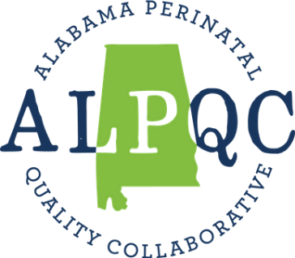

Step 2: Team Formation

- Select a pilot unit
This is the first patient care area in your hospital where testing of the concepts in the change package (toolkit) will occur. In a small hospital, it may not be necessary to select a pilot unit but in medium to large size hospitals, it’s more beneficial to begin testing in a focused location to keep the tests on a small enough scale and to allow for revision of the tests before implementation and spread occur. Ideally, hospitals would select a unit that has individuals who are excited about creating change and have a high tolerance for rapid change early on.

- Confirm Project Sponsor
In addition to the working members of your team, a successful improvement team needs a sponsor—someone with executive authority who serves as a liaison with other areas of the organization, provides structure to support the team effort, advocates for supportive policies, and allocates resources for improvement to overcome barriers. The Sponsor is not a day-to-day participant in team meetings and testing but reviews its progress on a regular basis.

The sponsor is responsible for:
- Encouraging the team to set its goals at an appropriate level to meet organizational goals
- Providing the team with the resources needed, including staff time and operating funds
- Making it clear to the team that they have the time, resources, and authority needed to change organizational systems to accomplish their goal
- Regularly reviewing the work of the team
- Developing a plan to spread the successful changes from the improvement team to the rest of the organization, including communicating what is learned from the improvement work in ways that motivate and mobilize the rest of the organization, and designating someone who will be responsible for leading the activities needed to support spread

- Select the day-to-day leader for the initiative
The day-to-day leader is the person who drives the project forward, ensures that changes are tested and implemented, and oversees data collection. It is important that this person understands the details of the system and the various levers for making changes in the system; and will be someone who can work effectively with the physician and nurse champions, other technical experts, and leaders. This person typically devotes a significant amount of time to the improvement team’s work. The main contact person identified on your Team Roster may be the same person who serves in this role, but not necessarily.
The day-to-day leader should be someone who:
- Has a working knowledge of the project topic
- Is in a position to carry the work of the improvement team beyond the pilot
- Is able to organize and coordinate a functioning team that is engaged in rapid cycles of improvement and has time allocated by senior leadership to work on this project
- Is motivated and excited about change and new designs to improve care

- Create your team
Your implementation team will guide the work and execute the tests of change throughout the Collaborative. Including the right persons in an improvement team is critical to the success of the improvement effort. Some helpful steps to consider:
- Review the project aim
- Consider the system that is related to the aim: what components of patient care will be affected by the improvement effort?
- Select team members that represent and are familiar with all the different parts of the process
It is critical to get all team members on board early in the process to build a strong foundation for driving the project forward. You will want to meet as a team at least monthly, likely more frequently at the beginning as you get the initiative established. For more information, see IHI’s Science of Improvement: Forming the Team.

- Fill out Team Roster
If you have not already done so, please fill out a Team Roster to help us better communicate with your team and keep everyone abreast of initiative information. You will find the Team Roster form here.

- Considerations of team rules, roles, and attributes
Determine your team’s ground rules - ex. meeting frequency, meeting venue/format, and meeting attendance. Agree on the roles of each team member, including who will prepare agendas, who will take notes, etc.

Consider the attributes of highly effective teams: highly effective teams don’t just happen! Time, cultivation, and attention are needed to create an environment for high-functioning teams. Here is a short list of attributes of such teams:
- The purpose and objectives of the team are clear
- The roles of team members are clear
- A climate exists that a) seeks and supports the participation of all team members, and b) supports problem-solving and learning
- Decision-making processes are clear
- Leaders model a clear conflict-resolution process
- The team practices good housekeeping: clear agendas, start and stop times, role assignments (facilitator, note taker, timekeeper)
- Leadership is distributed and shared among team members
- Team members’ strengths are utilized to the fullest
- The team encourages risk-taking and creativity
- The team has a method to assess itself as a team

Step 3: Fill out the ALPQC NHP Initiative baseline survey

Please fill out the ALPQC NHP Initiative baseline survey. This survey will help you assess your current practices at your facility, will help you determine what to first focus on during implementation, and will help us tailor technical assistance to teams. You will receive an email with a PDF of the survey questions for ease of gathering the answers needed, but please also feel free to reach out to our team at info@alpqc.org and we will share the PDF with you. Please aim to fill out the survey by March 31, 2024.

Step 4: Become familiar with resources on the NHP Initiative website

The NHP Collaborative website (www.alpqc.org/initiatives/nhp) is where you will find all materials needed for implementation, including how-to documents on entering and visualizing data in the portal.

Step 5: Become Familiar with the Model for Improvement

We will use a simple improvement approach for the NHP Collaborative called the Model for Improvement (MFI). The MFI will be taught at the Learning Sessions. However, if your team does not have experience with the MFI, we encourage your team to review some of the videos and resources below.

- An Illustrated Look at Quality Improvement in Health Care – 8 minute video
- The Model for Improvement (Part 1) – 3 minute video
- Science of Improvement: Testing Changes

